Software Requirements Specification
for
Facebook IE toolbar
Version 1.0
Lohika
20 January 2009
Table of Contents
1. Introduction 1
1.1 Purpose 1
1.2 Project Scope 1
2. Overall Description 2
2.1 Product Perspective 2
2.2 Product Features 2
2.2.1 Installation 2
2.2.2 Logon 2
2.2.3 Logout 3
2.2.4 Quick links drop down menu 3
2.2.5 Go home 3
2.2.6 Set status 3
2.2.7 Go to profile 3
2.2.8 Search Facebook from anywhere 3
2.2.9 Toolbar settings 4
2.2.10 Get notified by icons 4
2.2.11 Get notified by popup window 5
2.2.12 Facebook friends sidebar 5
2.2.13 Share Content 5
2.3 Operating Environment 6
2.4 Design and Implementation Constraints 6
2.5 User Documentation 6
2.6 Assumptions and Dependencies 6
3. External Interface Requirements 6
3.1 Software Interfaces 6
4. Other Nonfunctional Requirements 6
4.1 Security Requirements 6

Revision History

Name | Date | Reason For Changes | Version
Andriy Petlyovanyy | 20 Jan 2009 | Created | 1.0

Introduction

Purpose
Create Facebook Internet Explorer toolbar which will give users easy access to this social network.

Project Scope
Facebook Internet Explorer toolbar will be similar to already existing Firefox toolbar. Functionality and user interface will be the same as in already existing product.

Overall Description

Product Features

Installation
User has ability to install toolbar under Internet Explorer easily. There is web page on which user can click link and following instruction of the installer to get toolbar in their browser.

Logon
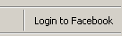
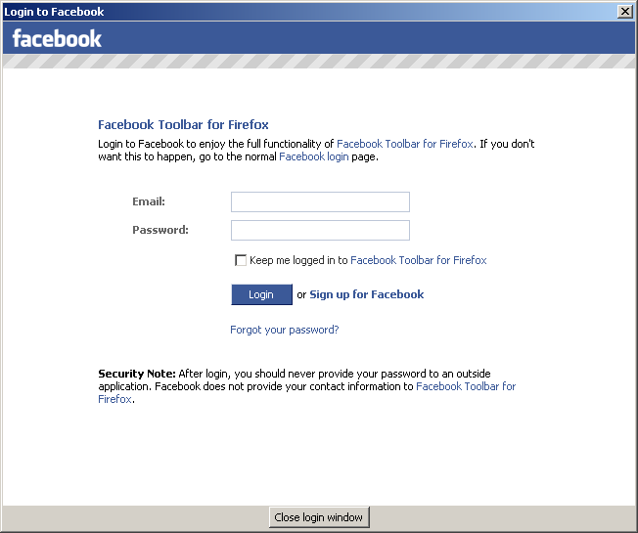
There is ability to login to Facebook from toolbar. Appropriate html dialog will appear which will request username and password and after that session would be established.

Logout
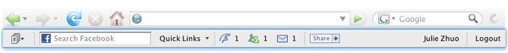
Users can simple logout from the system using Logout button on toolbar.

Quick links drop down menu
There is ability to go to most recent pages from drop down menu on toolbar.

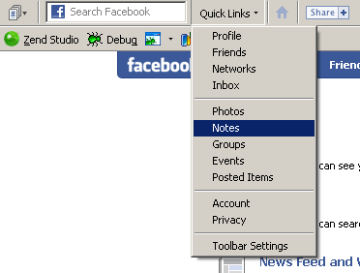

Go home
The button on the toolbar allows user to go to Facebook home page.

Set status
Toolbar is allowing to setup new custom status of the user in edit. After pressing enter notification about successful status update appear.

Go to profile
User can go to his/her profile by clicking on user’s name near custom status edit on the toolbar.

Search Facebook from anywhere
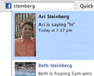
The Search Box allows you to easily search Facebook no matter where you are. Select a friend from the dropdown to go directly to their profile, or hit "enter" to see the search results.

Toolbar settings
User has ability to change some toolbar settings such as which notification s/he wants to receive.

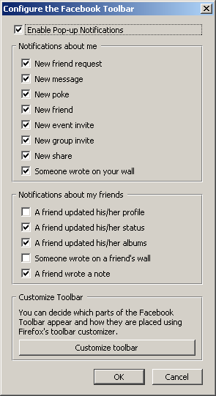

Get notified by icons
Icons on the toolbar tell you how many new pokes, friend requests, messages, event invitations, and group invitations you have.


Get notified by popup window
A pop-up will notify you when your friends update their statuses and profiles, upload new photos, write new notes, or interact with you on Facebook.
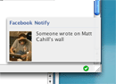

Facebook friends sidebar
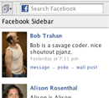
Click the icon to open the Facebook friends’ sidebar and check out your friends' profile pictures and statuses, along with convenient links for interacting with them on Facebook. You can sort your friends by name or by how recently they updated their status or profile.

Share Content

The Share button lets you share the page that you are currently browsing by sending it to friends or posting it to your profile. This button will popup window in which you can add website to shares or cancel this action.

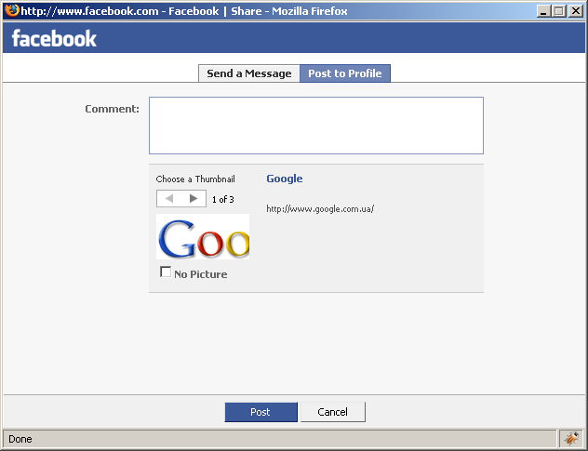

Operating Environment

Based on the following IE trends in IE usage v.7 is the most popular version.

IE 7.0 - 73.49%
IE 6.0 - 25.14%
IE 8.0 - 1.33%
IE 5.5 - 0.04%

The first version of the toolbar will be targeted for Internet Explorer version 7.0 in Microsoft Windows XP and Vista operation systems.

The final version of toolbar will be compatible with IE v6-8 versions.

Design and Implementation Constraints
Toolbar will be developed in C++ language. The project will be developed in Microsoft Visual Studio 2008 C++. All source code will follow Facebook C++ Coding Conventions and C++ Style.

User Documentation
The final product will be documented both inline as well as externally in the same manner the current Firefox toolbar is.

Assumptions and Dependencies
Toolbar will be similar in UI to Firefox toolbar. Also it will use the same interface to interact with the Facebook system.

External Interface Requirements

Software Interfaces
Internet Explorer Toolbar will interact with Facebook web service through HTTP. All information regarding person identify, friends etc.

Other Nonfunctional Requirements

Security Requirements
All personal information of the user should be protected to not allow other persons read it.

